**PROJECT REPORT**

**On**

**“ArogyaSetu”**



**Submitted By: Guided By:**

1. Shivendra Singh. Dr. Tanmay Kabse

2. Kunal Chauhan. Professor

3. Purnata Patidar. Oriental University, Indore

**CERTIFICATES**

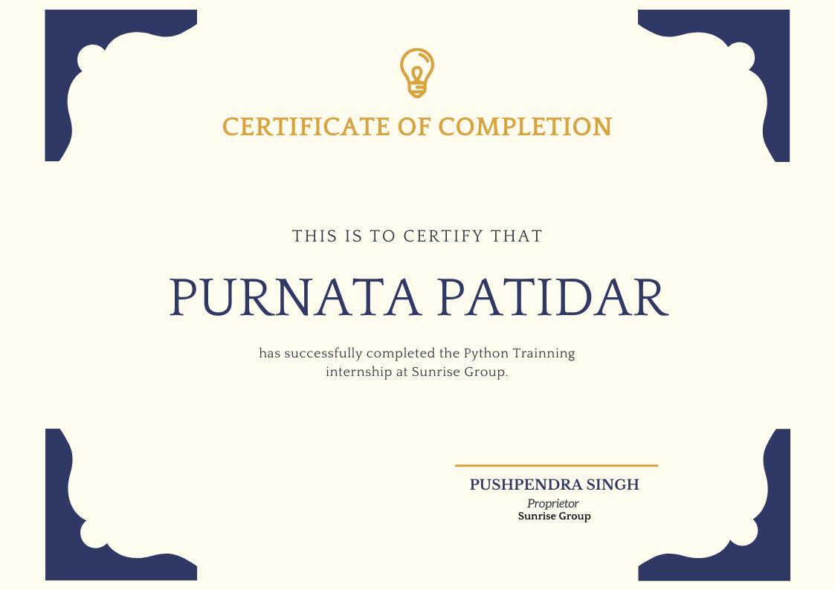

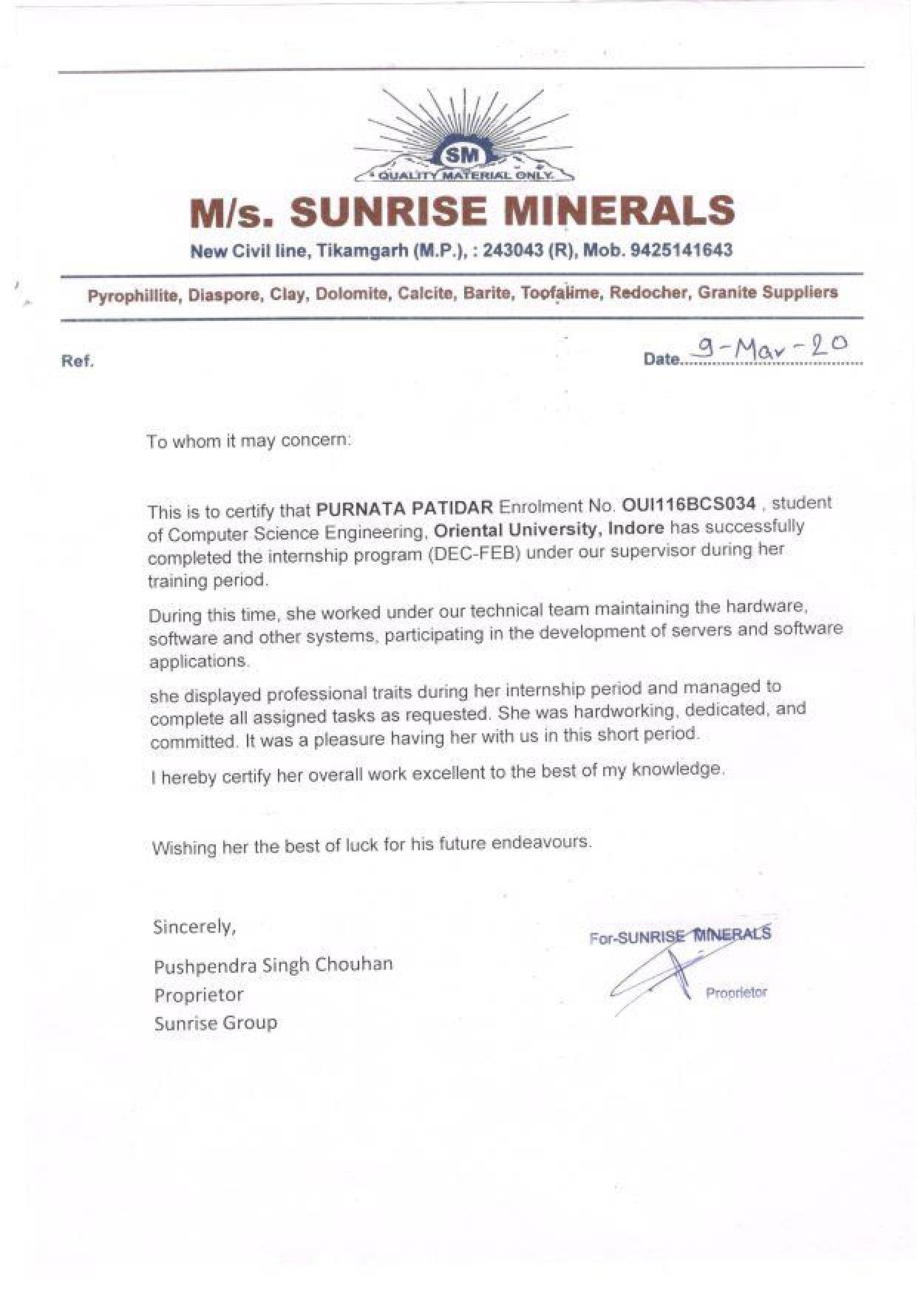

**ACKNOWLEDGMENT**

In performing our assignment, we had to take the help and guideline of our respected teacher, who deserve our greatest gratitude. The completion of this assignment gives us much Pleasure and satisfaction. We would like to show our gratitude to **Dr. Tanmay Kabse, Project Instructor & Professor, Oriental University**for giving us a good guideline for assignment throughout numerous consultations. We would also like to expand our deepest gratitude to all those who have directly and indirectly guided us in writing this assignment.

I am deeply grateful to our classmates and team members itself, for their ceaseless dedication and their valuable comment and suggestions on this proposal which gave us an inspiration to improve our assignment. We thank all the people for their help to complete our assignment.

Shivendra Singh

Kunal Chauhan

Purnata Patidar

**ABSTRACT**

This is a college project which is developed with keeping the global Corona virus pandemic in mind, the inspiration behind the project is to provide information, Self- assessment & safety guidelines on coronavirus. This is web application that allows users to login, Self Assess their heath and risk of getting infection, share information and best practices about coronavirus, connect symptoms and other related problems to coronavirus & spread awareness of COVID-19.

ArogyaSetu web application shows updates on the coronavirus cases in Indian states.

ArogyaSetu has these sections:

1. Your Status (tells the risk of getting COVID-19 for the user),

2. Self-Assess (lets the user know the risk of being infected),

3. COVID-19 Update (gives updates on local and national COVID-19 cases).

**CONTENTS**

**Chapter 1. Introduction**

1.1 Rationale

1.2 Problem Definition and Proposed Solution

1.3 Objective and Scope

**Chapter 2. Literature Surveys/Existing System**

2.1 Background

2.2 Research Work

2.3 Goals of Proposed System

**Chapter 3. System Analysis Requirement Specification**

3.1 Functional and Non-Function Requirement

3.1.1. Functional

3.1.2. Non- Functional Requirement

I. Performance Requirement

II. Reliability

III. Scalability

IV. Security

V. Testability

3.2 Hardware Requirement & Software Requirement

3.3 Requirement Study

3.4 Feasibility Study

**Chapter 4. System Design**

4.1 Unified Modeling Language

4.1.1 Structural model view

4.1.2 Behavioural Model View

4.1.3 Implementation Model View

4.1.4 Environmental Model View

4.2 Use case Diagram

4.3 Class Diagram

4.4 Activity Diagram

4.5 StateChart Diagram

4.6 Sequence Diagram

4.7 Entity-Relationship Diagram

4.8 Data Flow Diagram

**Chapter 5. Database Design**

**Chapter 6. Project Implementation and Output Screens**

6.1 Screenshots of Projects

6.2 Some code snippets

**Chapter 7. Testing**

7.1 Testing Strategy Adopted

7.2 Testing Strategy Adopted

7.3 Unit Testing

7.4 Test Plan & Test Cases

7.5 Types of Testing

**Chapter 8. Conclusion**

**Appendix**

**INTRODUCTION**

**1.1 Rationale**

The outbreak of coronavirus disease 2019 (COVID-19) has created a global health crisis that has had a deep impact on the way we perceive our world and our everyday lives. Not only the rate of contagion and patterns of transmission threatens our sense of agency, but the safety measures put in place to contain the spread of the virus also require social distancing by refraining from doing what is inherently human, which is to find solace in the company of others. Within this context of physical threat, social and physical distancing, as well as public alarm, the role of the internet is essential in our lives on individual, social and societal levels.

Internet can be reckoned as the latest discovery of man which has revolutionised his style of working and living. It has totally reduced distance, broken all man-made barriers and made our world a small place.

Access to the Internet and digital technologies has become essential for most of us in our everyday lives. Technology enables us to work, shop, communicate and access important services. Increasingly, technology is a key enabler for the exercise and enjoyment of many human rights, in particular the right to freedom of expression and information.

During a public health emergency, access to the internet becomes even more of an essential tool for protecting our health as well as a range of human rights, including our social and economic rights while our everyday movements are restricted. A lack of access to the Internet significantly impacts people’s lives during this time. The Internet enables us to receive and share vital information about the pandemic and the measures being put in place to tackle it. It helps us to understand and scrutinise our governments’ actions. And with approximately 20% of the world’s population social distancing or living under quarantine conditions, technology helps us to work, shop and communicate. A number of daily activities have shifted online, ranging from the provision of health services to education programmes that enable home schooling.

**1.2 Problem Definition and Proposed Solution**

Just a few months ago we were living a completely different life unaware of how rapidly things were going to change. The Coronavirus is a global disturbance that has forced us all to come together and try to put an end to it. While we are all making changes and doing what we can to help, there is still a lot more that needs to be done. We’ve seen some apps and websites pop up to try and provide information to help fight this **COVID-19 coronavirus pandemic**.

The stated purpose of ArogyaSetu web application is to spread awareness of COVID-19 and to connect essential COVID-19 - related health services to the people of India. This web application augments the initiatives to contain COVID-19 and shares best practices and advisories. It is a web application which is based upon the Arogyasetu mobile application.\

**1.3 Objective & Scope:**

We wanted to join in the fight to create a website that provides information globally but also could actually help put an end to this. We kept in mind several parameters to develop ArogyaSetu web application, that can be used to as close to accurate as possible.

**1. How to avoid getting it**

There is so much information out there that it can be overwhelming. Gathering the correct information and making it concise. Quick and easy for anyone to understand exactly what precautions they need to take to avoid catching it. There’s the basic information such as avoiding people and washing your hands consistently but dive a bit deeper into all the things they should be doing and why.

**2. What the symptoms are**

People may already know the basics of what they can expect if they have the virus such as a cough and fever. However, providing more specifics about it because this will help people better understand if they have the coronavirus versus the flu or cold. There are differences no matter how subtle. We want people to avoid panic and trying to go to the hospital so helping them understand a deeper understanding of the symptoms will help greatly.

**3. Self-Assessment**

If people think they might have it or want to test for it, we are offering a way to do this within the ArogyaSetu website itself. While the physical testing tools are mandatory and temperature readings are necessary for a exact test result. We are adding a Self-Assessment section for the users to check the symptoms of their sickness. Not everyone has the ability to get tested so being able to do it within ArogyaSetu website is a great option.

**4. Helping with national funding**

Mostly everyone wants to contribute to the coronavirus pandemic fighting funds. We have added the information on national COVID emergency fund, such as PM CARES. It has all the information listed such as account name, account number, various e-payment systems and UPI. This is a fund started by the Prime Minister Narendra Modi of India. It is one more step closer to providing correct information on ArogyaSetu to help advance the recovery of the nation & its citizens from the Coronavirus Pandemic.

**5. What to do once you think you have it**

Once someone realizes you have the Coronavirus, then there is the stress of what to do next. Information all over says to simply stay home but there is a lot more to it than that. Much like the details for avoiding the virus, quick and concise details on what to do once you have it is also needed. We’re so overwhelmed with all this information that it can be difficult to understand what you should actually do. Most people’s instincts are going to be to head to the hospital but before they do our information on ArogyaSetu website can help guide them much faster and easier.

**6. Updates on current coronavirus**

The user wants to receive live coronavirus updates about where they or their loved ones live. Showing a quick view of how many have it, how many have died, and how many have recovered is important. We have segregated the information on the basis of states to provide a more focused view on areas. This should be a daily update to stay as accurate as possible.

**7. Numbers to call for more information and emergencies**

Quick access to the most important numbers for people to call is a necessity. This includes a list of the hospitals in their area, specific coronavirus emergency numbers, and more. Even numbers to learn more information is provided as well.

**8. Coronavirus health alert**

Users should have the ability to receive alerts. These alerts should be sent to notify individuals of very important updates. This can include many things for instance if new testing equipment has become available. This pandemic is not being taken lightly; we all want to know what’s happening right away.

Here we mention some future scope of ArogyaSetu Website that can help user grow:

* **Improves patient selfcare**- Improved services for indoor and outdoor patients is a backbone of the healthcare-related business-like website & mobile application. Do you know that over 93 percent of doctors are of opinion that healthcare apps can improve the patient care? When it comes to checking all the records at a stretch especially during any emergency situation, the ArogyaSetu website makes it easy. The customized ArogyaSetu Website also enables the medical professionals to prepare a specific approach for every patient.
* **Reduces distance**- The prevalence of smartphones has reduced the geographical distance with the help of the Internet. ArogyaSetu website has brought the health services at fingertips even if people reside in far-flung areas. It is easy to implement the concept of a feature-rich ArogyaSetu Assessment website. Also, ArogyaSetu website can add push notification to enable the users to get important healthcare tips regularly.
* **Manages appointments**- In distant future, if we develop a ArogyaSetu mobile Healthcare application, we can opt for iPhone or Android app development services, you get the appointment management as a default function. The app users can schedule a quick appointment, find the specialist, view their test reports, order medicines, and consult the doctor by using the app. The video chat can give users a facility to meet the doctor face-to-face for discussing their health-related issues. On the other hand, the doctors or healthcare professionals can readily view the appointments and manage their time accordingly through the app.
* **Integrates technologies**- The Scope of Healthcare application are getting vast. Futuristic technologies like Internet of Things (IoT), VR (Virtual Reality), and AR (Augmented Reality) can be easily integrated into the healthcare apps to get optimum outcome regarding efficient collaboration and effective cooperation. Also, the disruptive IoT technology can enable the healthcare professionals to manage their resources. The integration of these technologies in the app also facilitates the professionals to monitor the vital parameters of their patients.
* **Brings new opportunities**- One of the biggest advantages of a healthcare application is it can bring new opportunities and business model to expand the services. These days, diversification is prevalent in the healthcare sector also and people use the healthcare apps for different purposes like getting health tips, checking test reports, and finding the real-time data of various parameters like heart rate, blood sugar, etc. A feature-rich app can help them achieve these objectives and you can give the special features in a premium version to

generate more revenue.

* **Promotes accuracy**- In the medical and healthcare services, there is no room for error. The mobile app for health services can help you mitigate the risks of the wrong diagnosis with a real-time access of accurate data of every patient. On receiving the accurate report of the health condition, the specialists can prescribe the most accurate medicine. Also, if the patient has any kind of allergy or similar issues, the healthcare service provider can immediately know them through an app and start the treatment accordingly. Even the paramedics and other staff can also get a real-time access to the precise data to treat the patients in a better way. Ultimately, it helps the healthcare service providers tackle the emergency situation more efficiently.
* **Facilitates payment**- Now, your patients or their relatives have no need to stand in a queue to pay the bill. People can pay the medical expenses on the move in a secure way through apps. In a way, a mobile healthcare app can increase the convenience and manage the payment process efficiently. You can also integrate the notifications feature to send notification for sending receipts or reminders of the medical bill to the patients.
* **Enhances brand value**- Just like any other business, the healthcare service providers also face tremendous competition. In such a scenario, a mobile healthcare app with desired features can give your business an edge over your peers who have not come up with a customized app. The app can also boost your online presence and show your expertise and authenticity in the domain.

**Literature Surveys/Existing System**

**2.1 Background:**

When people started capitalizing on the varied uses of internet, they understood the immense power it had. Regardless of what topic you want to know about, the internet is a knowledge hub with all kinds of details in it. You can research about absolutely any topic and even contribute to the knowledge repository too.

In July 2016, the United Nations declared access to the Internet to be a human right. During the coronavirus pandemic, it has become even clearer that access to the Internet and digital technologies can be a lifesaver for many people around the world. Health related information can reduce the spread of the virus and save lives, while many online services can help us to live normally when our movements are restricted. Governments and telecommunication and Internet service providers (Telco’s and ISPs) must do everything they can to guarantee and enable people’s access to the Internet, in full compliance with international standards.

At the outset, web designing emerged as an easier and simple way of exchanging information. It was a better means of communication and had better networking benefits compared to the commercial reasons. Later on, the Web became an avenue for making profits, and the information space that was prior for providing free exchange thus changed to a space for commercial transactions. We moved from ambiguity and desktop networks to graphic design, mobile web, responsive web design, etc. With web design technologies such as HTML 5 and CSS 3, web design has evolved from service masteries to content of services and various screen sizes. When talking about web design, it is difficult to talk about browsers. That is where all the designs and functions run on our machine.

**2.2 Study of Aarogya Setu Mobile Application by Govt. of India**

**Aarogya Setu** is a mobile application developed by the Government of India to connect essential health services with the people of India in our combined fight against COVID-19. The App is aimed at augmenting the initiatives of the Government of India, particularly the Department of Health, in proactively reaching out to and informing the users of the app regarding risks, best practices and relevant advisories pertaining to the containment of COVID-19.

**Aarogya Setu** is an open-source Indian CoVID-19 Contact tracing, Syndromic mapping and Self-assessment digital service, primarily a mobile application, developed by the National Informatics Centre under the Ministry of Electronics and Information Technology (MeitY).

It is a tracking app which uses the smartphone's GPS and Bluetooth features to track the coronavirus infection. The app is available for Android and iOS mobile operating systems. With Bluetooth, it tries to determine the risk if one has been near (within six feet of) a COVID-19 - infected person, by scanning through a database of known cases across India. Using location information, it determines whether the location one is in belongs to one of the infected areas based on the data available

Aarogya Setu mobile application provides the following features:

* Minimal and simple user interface, which user can get easily acquainted with
* Scan nearby Aarogya Setu user using BluetoothLE Scanner
* Advertise to nearby Aarogya Setu user using BluetoothLE GATT Server
* Update user about nearby activity using Location Service
* Secure information transfer with SSL Pinning
* Encrypt any sensitive information
* Available in 12 different languages
* Nationwide COVID-19 Statistics
* Self-Assessment as per MoHFW and ICMR guidelines
* Emergency Helpline Contact
* List of ICMR approved labs with COVID-19 testing facilities
* e-Pass integration

The app reached 100 million installs in 40 days. On 26 May 2020 the government made the source code for android app public on Github, which will be followed by IOS and API documentation. The Government has also launched a bug bounty program.

The App has been highly successful in identifying people with high risk of COVID-19 infection and has also played a major role in identifying potential COVID-19 hotspots. In the larger public interest and in order to help the international community in their COVID-19 efforts, the Government of India is opening the source code of this App under Apache License 2.0.

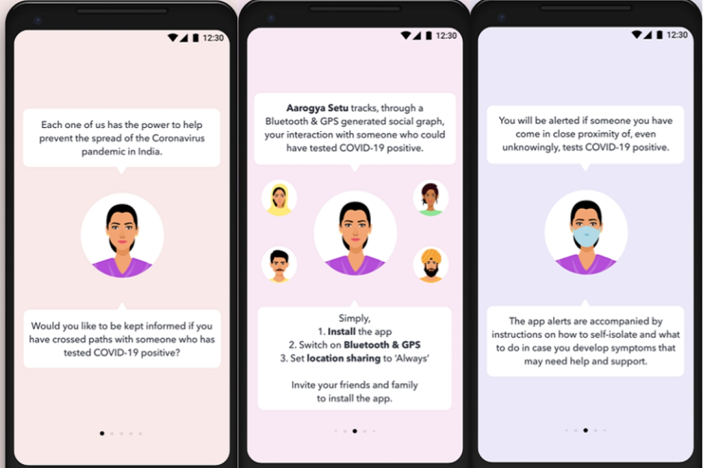

Figure 1

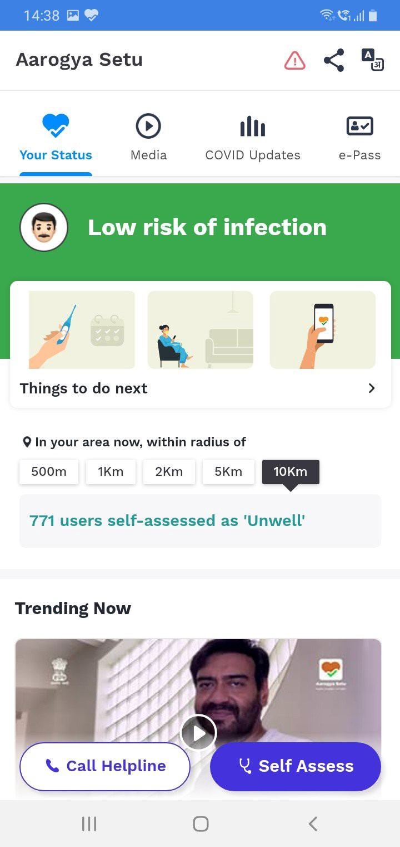

Figure 2

**2.3 Goals for Health service website and mobile application**

The goal of health services is to protect and improve the health of individuals and populations.

**Patient Safety:** Patients should not be harmed by health care services that are intended to help them. The IOM report, To Err Is Human, found that between 46,000 and 98,000 Americans were dying in hospitals each year due to medical errors. Subsequent research has found medical errors common across all health care settings. The problem is not due to the lack of dedication to quality care by health professionals, but due to the lack of systems that prevent errors from occurring and/or prevent medical errors from reaching the patient.

**Effectiveness:** Effective care is based on scientific evidence that treatment will increase the likelihood of desired health outcomes. Evidence comes from laboratory experiments, clinical research (usually randomized controlled trials), epidemiological studies, and outcomes research. The availability and strength of evidence varies by disorder and treatment.

**Timeliness:** Seeking and receiving health care is frequently associated with delays in obtaining an appointment and waiting in emergency rooms and doctors’ offices. Failure to provide timely care can deny people critically needed services or allow health conditions to progress and outcomes to worsen. Health care needs to be organized to meet the needs of patients in a timely manner.

**Patient Centric:** Patient-centric care recognizes that listening to the patient’s needs, values, and preferences is essential to providing high-quality care. Health care services should be personalized for each patient, care should be coordinated, family and friends on whom the patient relies should be involved, and care should provide physical comfort and emotional support.

**Efficiency:** The U.S. health care system is the most expensive in the world, yet there is consistent evidence that the United States does not produce the best health outcomes or the highest levels of satisfaction. The goal is to continually identify waste and inefficiency in the provision of health care services and eliminate them.

**Equity:** The health care system should benefit all people. The evidence is strong and convincing that the current system fails to accomplish this goal. The IOM report, Unequal Treatment, documented pervasive differences in the care received by racial and ethnic minorities. The findings were that racial and ethnic minorities are receiving poorer quality of care than the majority population, even after accounting for differences in access to health services.

**System Analysis Requirement Specification**

Analysis is mainly focused on requirement gathering, fact finding the functional and non-functional requirement of the system. At the same time, brief analysis of existing chatbot system is also discussed. Once analysis is completed successfully, can move design phase.

A collection of components that work together to realize some objectives forms a system. Basically, there are three major components in every system, namely input, processing and output.

**Input Processing Output**

Basic System Components

The Objective of the system demands that some output is produced as a result of processing the suitable inputs. A well-designed system also includes an additional element referred to as ‘control’ that provides a feedback. Requirement Analysis means studying or observing the current Business System to find how it works and where improvement can be made. It may include ways of capturing or processing data, producing information, or supporting management.

In this case the current business system is manual and takes lot of money to publish books and multiple copies of books and this problem can be solved if user uploads his books and allows persons to download them without creating multiple copies of books.

The First step of System Analysis is the identification of need. In this regard a series of interviews were conducted with authorized person of the institution. This was essential so as to know the processes that were being followed.

In the detailed design stage, computer-oriented work begins in earnest. In this stage, the design of the system becomes more structured. Structure design is blue print of a computer system solution to a given problem having the same components and inter-relationships among the same components as the original problem. Input, Output, databases, forms, codification schemes and processing specifications are drawn up in detail. In the design stage, the programming language and the hardware and software platform in which the new system will run are also decided. This application will be very vast, the feature of E-commerce is also suppressed in this application and for that at this student level of project development we are using the e-commerce dummy application development for providing the dynamic feature to this site.

Main emphasis should be on**:**

* Inputs enter into the system.
* Standard Encryption of Input on submit
* The outputs expected from the system.
* The people involved in the working of the system.
* The volume of DATA (INPUT) and the amount of Information (OUTPUT) that will be involved with respect to the system itself, the following facts should be taking into consideration.

The Major process involved:

* The main points of the application.
* The processing rules fort he collected data.
* The exceptions that may be present.

That checks that should be in place in order to avoid wrong entries.

**3.1 Functional Requirement & Non-Functional Requirement:**

**3.1.1 Functional Requirement**

In this section we will briefly discuss different functional requirement of different users.

**Admin**

1. Add new information Related to COVID status, safety guidelines and research work.
2. Ability to change the look and feel of Web Application.
3. Add/Update/Delete information from database.
4. Can view/delete feedback.
5. Can change the server and the language.

**User**

1. Ability to self-assess.
2. Ability to view coronavirus status.
3. Ability to view coronavirus information .
4. Ability to register & login.

**3.1.2 Non-Functional Requirement**

In this section we will briefly discuss different non-functional requirement.

**Reliability:** The ArogyaSetu is reliable.

**Availability:** The ArogyaSetu is easily available to user.

**Security:** The ArogyaSetu has security.

**Maintainability:** The ArogyaSetu is having low cost maintenance.

**Portability:** The ArogyaSetu is easily portable as it run as web application.

**Performance:** The ArogyaSetu has great performance**.**

**Database Requirement:** the ArogyaSetu can store a large database.

**3.2 Hardware Requirement & Software Requirement:**

**Hardware Requirement**

In hardware requirement we require all those components which will provides us the platform for the development of the project. The minimum hardware required for the development of this project is as follows: -

Processor : Pentium-IV

Processor speed : 2.4GHZ

Monitor : Colour Monitor

Hard Disk : 50 GB

RAM : 2 GB

Mouse : Scrolling mouse

Keyboard : MM keyboard

**Software Requirement**

Operating System: Windows 98 & above, Unix/Linux, MacOS

Browsers: Google Chrome, Mozilla Firefox, Safari, Opera

Front-End: HTML, CSS, Bootstrap, JavaScript

Web framework: Django

Back-End: Python

Database: SQLite

**Communication protocols**

* TCP/IP protocol should be installed.
* Any browser should be installed (Google Chrome or Mozilla Firefox)
* HTTP 1.1 should be present on the system.
* Internet connection should be present in order to access the site.

**3.3 Requirement study**

The origin of most software systems or web application is in the need of a client, who either wants to automate and existing manual system or desires a new web application. The web application itself is created by the developer finally the completed system will be used by the end user. Thus, there are three major parties interested in a new system: the client, the users, and the developer. The requirements for the system that will satisfy the need of the clients and the concerns of the user have to communicate to the developer.

The problem is that the client usually does not understand software or the software development process, and the developer often does not understand the client’s problem and application area. This causes a communication gap between the parties involved in the development project. A basic purpose of software requirement specification is to bridge this communication gap. SRS is the medium through which the client and the user need are accurately specified; indeed, SRS forms the basis of software development. A good SRS should satisfy all the parties-something very hard to achieve and involves trade-offs and persuasion.

**The Requirement Process:**

The main reason of modeling generally focuses on the problem structure, not its external behaviours. Consequently, thing’s like user interfaces are rarely modeled, whereas they frequently form a major component of the SRS.

Similarly, performance constraints, design constraints, standards compliance, recovery, etc. are specified clearly in the SRS because the designer must know about there to properly design the system.

To properly satisfy the basic goals, an SRS should have certain properties and should contain diff type of req. A good SRS is [iEE87, IEE94]: complete if everything the software is supposed to and responses to the software to all classes of input data are specified in the SRS.

Correctness and completeness go hand in hand an SRS in unambiguous if and only if every requirement stated has one and only one interpretation, requirements often written in natural language.

An SRS is verifiable if and only if every stated requirement is verifiable. A requirement is verifiable if there exists some cost-effective process that can check whether the final software meets those requirements. An SRS is consistent if there is no requirements that with another.

Writing and SRS is an iterative process. Even when requirement of system are specified they are later modified as the need of the client change. Hence an SRS should be easy to modify. An SRS is traceable if the origin of each of its requirements is clear and if it facilitates the referencing of each requirement in future development [EEE87].

One of the most common problems in requirement specification is when some of the requirements of the client are not specified. This necessitates addition and modifications to the requirements later in the development cycle, which are often expensive to incorporate.

**Project Schedule Study phase:**

In the study phase we do the preliminary investigation and determine the system requirements. We study the system and collect the data to draw the dataflow diagrams. We follow the methods like questions and observation to find the facts that are involved in the process. This is an important because if the specification study is not done properly then design phase etc will go wrongly.

**Design Phase:**

In this design phase we design the system making use of study phase and the data flow diagrams. We make use the general access for designing.

We consider the top down approach. In the design phase we determine the entities and their attributes and the relationships between the entities. We do both logical and physical design of the system.

**Development Phase:**

In the development phase we mostly do the coding part following the design of the system. We follow modular programming for development and after development and after developing each and every module we do the unit testing followed by the integration testing.

**Implementation Phase:**

The last phase of the project is the implementation phase. Quality assurance is the primary motive in this phase. The quality assurance is the review of software products and related documentation for completeness, correctness, reliability and maintainability. The philosophy behind the testing is it finds errors. The testing strategies are of two types, the code testing and the specifications testing. In the code testing we are examining the logic of the program. On the surface, code testing seems to be ideal methods for testing software, but not all software errors are uncovered.

**3.4 Feasibility Study**

Feasibility is an important phase in software development process. It enables the developers to have an assessment of the product being developed. It refers to the feasibility study of product in terms of outcomes of the product, operational use and technical support required for implementation it.

Eight steps involved in the feasibility analysis are:

* Form a project team and appoint a project leader.
* Prepare system flowcharts.
* Enumerate potential proposed system.
* Define and identify characteristics of proposed system.
* Determine and evaluate performance and cost effective of each proposed system.
* Weight system performance and cost data.
* Select the best-proposed system.
* Prepare and report final project directive to management.

Feasibility study should be performed on the basis of various criteria and parameters. The various feasibility studies are:

1. Economic Feasibility

2. Operational Feasibility

3. Technical Feasibility

**1. Economic Feasibility**

It refers to the benefits or outcomes we are deriving from the product as compared to the total cost we are spending for developing the product.

In the present system, the development of new product greatly enhances the accuracy of the system and reduces the delay in the processing of applications and generating the reports. The errors can be greatly reduced and at the same time providing the great level of security. Here we don’t need additional equipment except memory of required capacity. No need for spending money on client for maintenance because the database used is web enabled database.

The financial and the economic questions during the preliminary investigation are

verified to estimate the following:

* The cost to conduct a full system investigation.
* The cost of hardware and software for the class of application being considered.
* The benefits in the form of reduced cost.
* The proposed system will give the minute information, as a result the performance is improved which in turn may be expected to provide increased profits.
* This feasibility checks whether the system can be developed with the available funds. The ArogyaSetu does not require enormous amount of money to be developed. This can be done economically if planned judicially, so it is economically feasible. The cost of project depends upon the number of manhours required.

**2. Operational Feasibility**

It refers to the feasibility of the product to be operational. Some products may work very well at design and implementation but may fail in the real time environment. It includes the study of human required and their technical expertise.

In the present system, the entering the details, updating the details and reports generations are perfect and quick in operations.

**3. Technical Feasibility**

It refers to whether the software that is available in the market fully supports the present application .It studies the pros and cons of using particular software for the development and its feasibility. It also studies the additional time needed to be given to people to make the application work.

In the present system the user interface is user friendly and does not require much expertise and training .It just needs mouse click to do operations and to generate reports. The software that is used for developing is highly suitable for the present applications since the users require fast access to the web pages with a high degree of security. This is achieved through integration of web server and database server in the same environment.

The technical needs of the system may include:

**Front-end and back-end selection**

An important issue for the development of a project is the selection of suitable front-end

and back-end. When we decided to develop the project, we went through an extensive

study to determine the most suitable platform that suits the needs of the organization as

well as helps in development of the project.

The aspects of our study included the following factors.

**Front-end selection**:

1. It must have a graphical user interface that assists employees that are not from IT

background.

2. Scalability and extensibility.

3. Flexibility.

4. Robustness.

5. According to the organization requirement and the culture.

6. Must provide excellent reporting features with good printing support.

7. Platform independent.

8. Easy to debug and maintain.

9. Event driven programming facility.

10. Front end must support some popular back end.

**Back-end Selection:**

1. Multiple user support.

2. Efficient data handling.

3. Provide inherent features for security.

4. Efficient data retrieval and maintenance.

5. Stored procedures.

6. Popularity.

7. Operating System compatible.

8. Easy to install.

9. Various drivers must be available.

10. Easy to implant with the Front-end.

The technical feasibility is frequently the most difficult area encountered at this stage. It is essential that the process of analysis and definition be conducted in parallel with an assessment to technical feasibility. It centres on the existing computer system (hardware, software etc.) and to what extent it can support the proposed system.

**SYSTEM DESIGN**

System design is the process, which involves conceiving planning and carrying out the plan by generating the necessary reports and inputs. In other words, design phase acts as bridge between the software requirement specification and implementation phase, which satisfies those requirements. System design is the transformation of the analysis model into a system design model.

The design of the system is correct if a system built precisely according to the requirements of that system. Design should be clearly verifiable, complete and traceable. The goal is to divide the problem into manageably small modules that can be solving separately. The different modules have to cooperate and communicate together to solve the problem. The complete project is broken down into different identifiable modules. Each module can be understood separately. All the modules at last are combined to get the solution of the complete system.

**4.1 Unified Modeling Language Diagrams**

* The unified modeling language allows the software engineer to express an analysis model using the modeling notation that is governed by a set of syntactic semantic and pragmatic rules.
* A UML system is represented using five different views that describe the system from distinctly different perspective. Each view is defined by a set of diagram, which is as follows.

**4.1.1 Structural model view**

* In this model the data and functionality are arrived from inside the system.
* This model view models the static structures.

**4.1.2 Behavioural Model View**

* It represents the dynamic of behavioural as parts of the system, depicting the interactions of collection between various structural elements described in the user model and structural model view.

**4.1.3 Implementation Model View**

* In the structural and behavioural as parts of the system are represented as they are to be built.

**4.1.4 Environmental Model View**

* In this structural and behavioural aspects of the environment in which the system is to be implemented are represented.

UML is specifically constructed through two different domains they are

* UML Analysis modeling, this focuses on the user model and structural model views of the system.
* UML design modeling, which focuses on the behavioural modeling, implementation modeling and environmental model views.

**4.2 Use case Diagram**

Use case diagram are set of use cases, actor and their relationship. They represent the use case view of a system. A use case represents a particular functionality of a system. So use diagram is used to describe the relationship among the functionalities and their internal/external controllers. These controllers are known as actor.

**Use Case Description**

* **Use case:** describe a sequence of actions that provides something of measurable value to an actor and is drawn as horizontal eclipse. A use case is a technique for capturing potential requirements of a new system or software change. Each use case provides one or more scenarios that convey how the system should interact with the end user or another system to achieve a specific goal. **Figure 3** shows use case diagram for ArogyaSetu which has different use cases such as login, status , self-assessment etc.
* **Actor:** An actor portrays any entity (or entities) that perform certain roles in a given system. An actor in a use case diagram interacts with a use case. In ArogyaSetu we have user, admin as an actor.

|  |  |
| --- | --- |
| **Actors** | **Description** |
| User | Can self-assess and view their status and updates. |
| Admin | Update the Database of Information. |

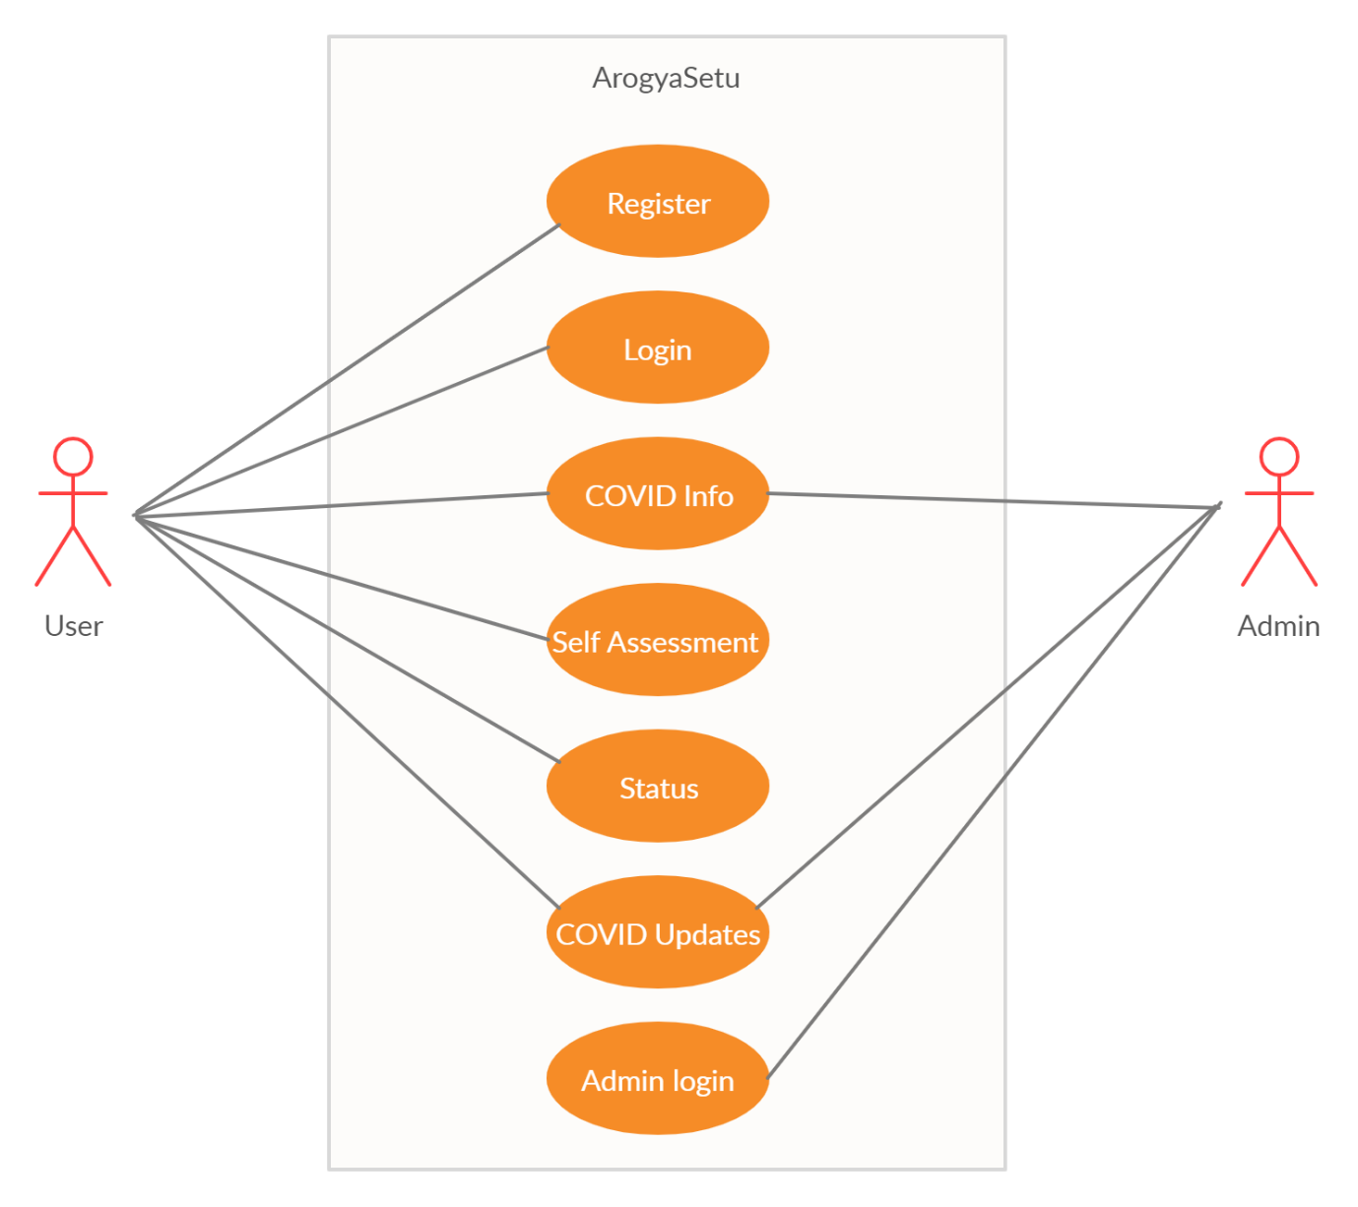

Figure 3:- Use case diagram for ArogyaSetu

|  |  |
| --- | --- |
|  |  |

* **Pre-conditions:** Pre-conditions that need to be satisfied for the use case to perform or pre-condition are tests that must prove true before the use is allowed to proceed. However, unlike assumptions that are handle by another use case, pre-conditions are checked by the use cases that contain the precondition.

Pre-condition in ArogyaSetu are: user should have Application and stable internet connection so by which he can view information.

* **Post-conditions:** Define the different states in which you expect the system to be in, after the use case executes. Good design requires that processes clean up after themselves so that subsequent processes are not corrupted. Post conditions identify items that the use case must handle before terminating.

Post-conditions for ArogyaSetu is regular update of information regarding coronavirus and updates on infection status. Admin provide the updated information about coronavirus and scientific research on regular basis from genuine .

* **Basic Flow:** List the basic events that will occur when this use case is executed. Include all the primary activities that the use case will perform. This use case starts when a user wishes to view information.

1. The website requests user to do self-assessment.
2. The user enters the self-assessment.
3. Website validates the entered queries and fetches the information from database.

* **Alternative flows:** Any subsidiary events that can occur in the use case should be listed separately. Each such event should be completed in itself to be listed as an alternative flow. A use case can have as many alternative flows as required. If there are too many alternative flows, make it simpler and, if required, break the use case into smaller discrete units.

In ArogyaSetu if a user enters invalid assessment then system display error message. The user can choose to either return to beginning of basic flow or close the web Application at which point log ends.

* **Special Requirements:** Business rules for the basic and alternative flows should be listed as special requirements in the use case narration.

**4.3 Class Diagram**

**UML Class diagram** gives an overview of a software system by displaying classes, attributes, operations, and their relationships. This Diagram includes the class name, attributes, and operation in separate designated compartments.

Class Diagram defines the types of objects in the system and the different types of relationships that exist among them. It gives a high-level view of an application. This modeling method can run with almost all Object-Oriented Methods. A class can refer to another class. A class can have its objects or may inherit from other classes.

Class Diagram helps construct the code for the software application development.

Essential elements of UML class diagram are:

1. Class Name
2. Attributes
3. Operations

**Classes:** A template for creating objects and implementing behaviour in a system. In UML, a class represents an object or a set of objects that share a common structure and behaviour. They're represented by a rectangle that includes rows of the class name, its attributes, and its operations. When you draw a class in a class diagram, you're only required to fill out the top row—the others are optional if you'd like to provide more detail.

* **Name:** The first row in a class shape.
* **Attributes:** The second row in a class shape. Each attribute of the class is displayed on a separate line.
* **Methods:** The third row in a class shape. Also known as operations, methods are displayed in list format with each operation on its own line.

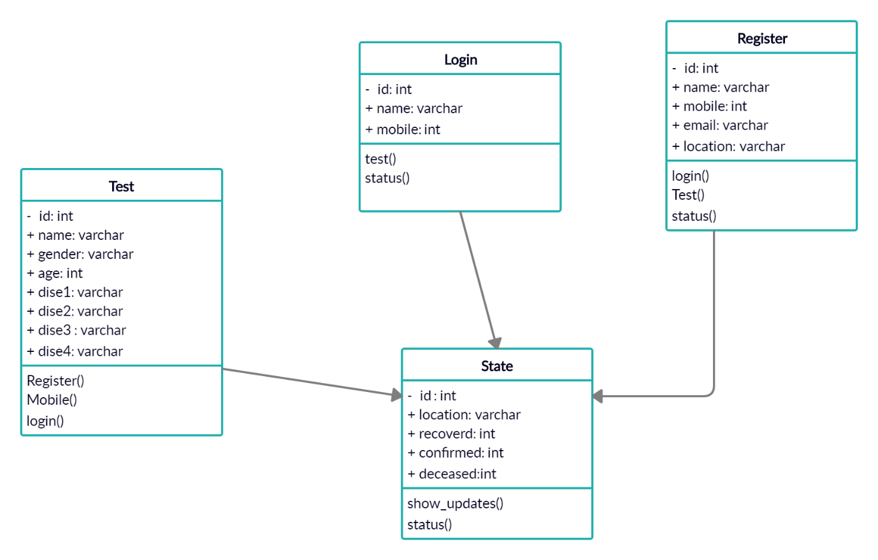

Figure4:- class diagram for ArogyaSetu’

**4.4 Activity Diagram**

Activity diagram describes the flow of control in a system. So, it consists of activities and links. The flow can be sequential, concurrent or branched. Activities are nothing but the functions of a system. Numbers of activity diagrams are prepared to capture the entire flow in a system. Activity diagrams are used to visualize the flow of controls in a system. This is prepared to have an idea of how the system will work when executed.

Activity diagrams symbol can be generated by using the following notations:

* **Initial states**: The starting stage before an activity takes place is depicted as the initial state
* **Final states**: The state which the system reaches when a specific process ends is known as a Final State
* State or an activity box:
* **Decision box**: It is a diamond shape box which represents a decision with alternate paths. It represents the flow of control.

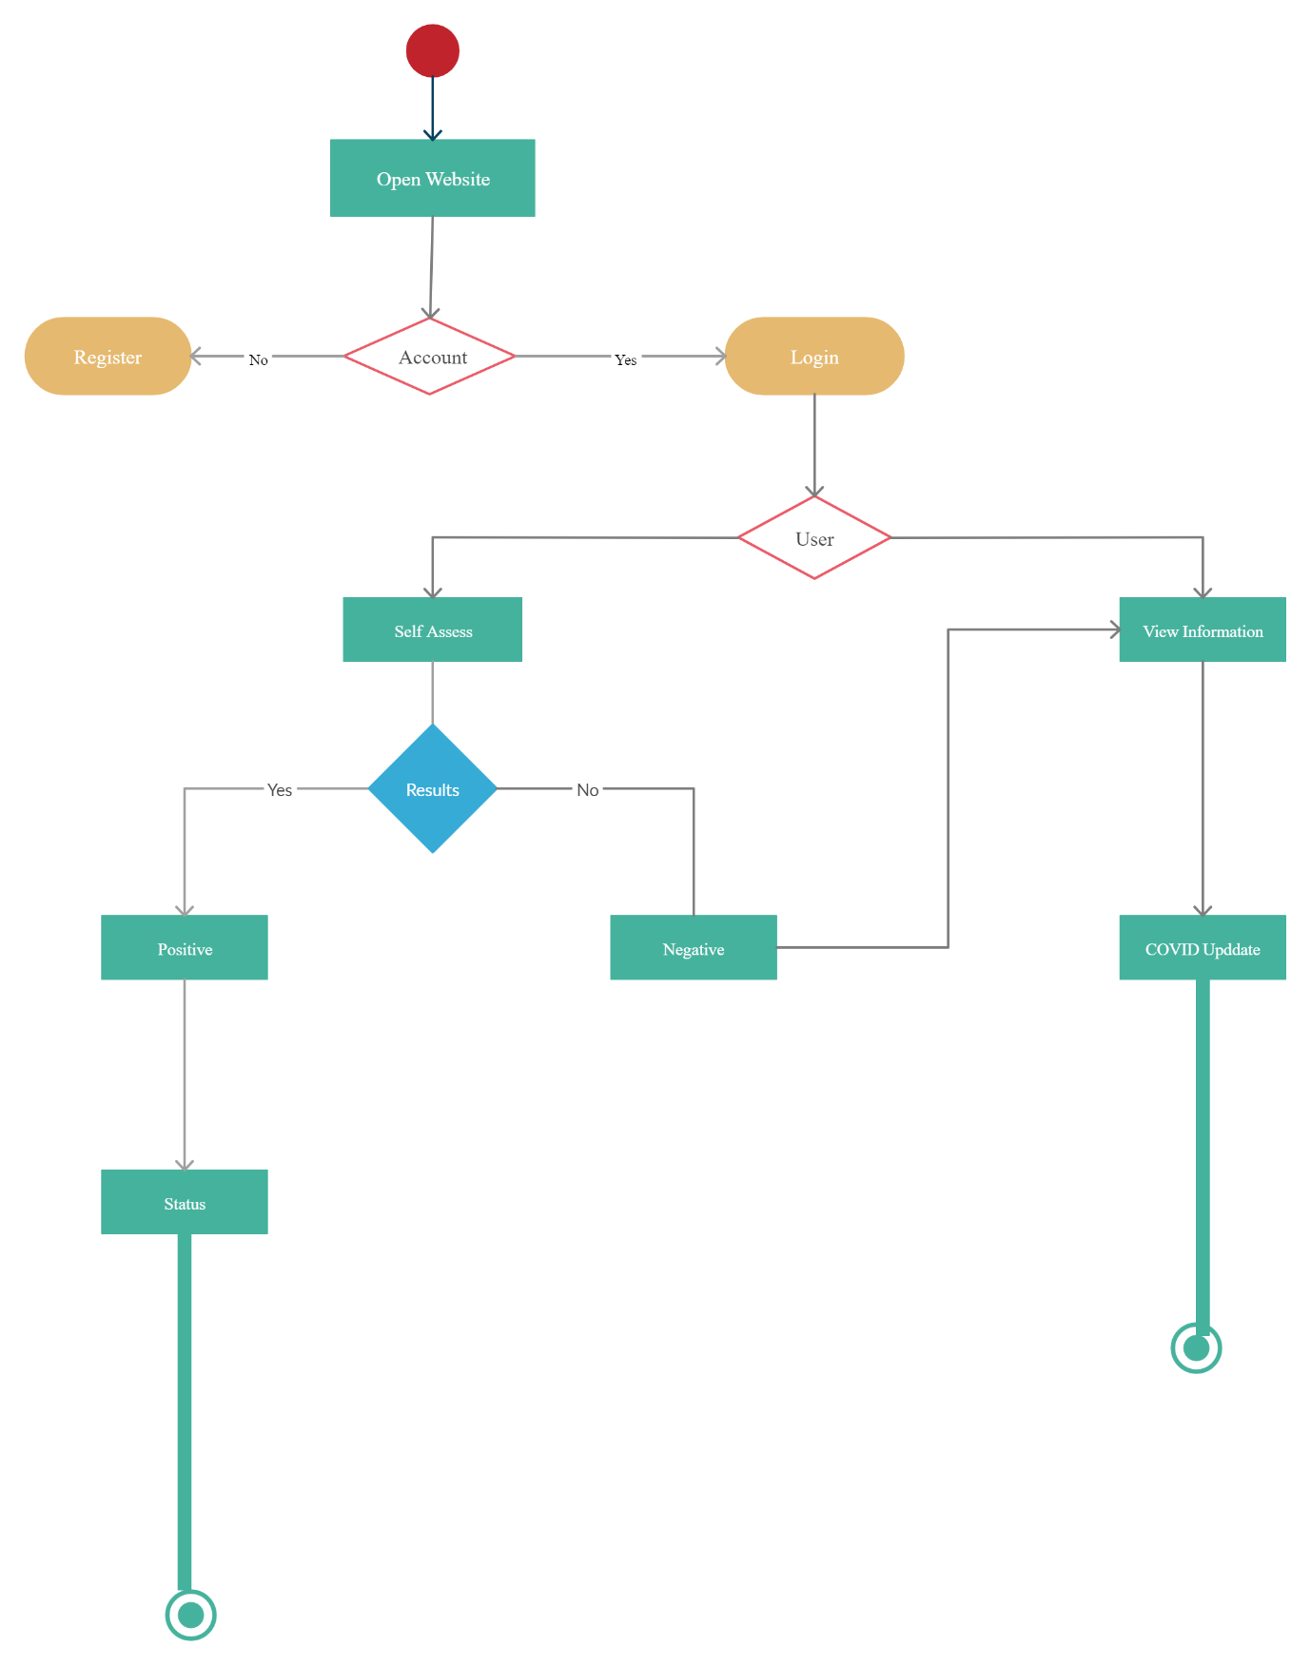

Figure 5:- Activity Diagram of ArogyaSetu

**4.5 StateChart Diagram for Users**

Statechart diagram is one of the five UML diagrams used to model the dynamic nature of a system. They define different states of an object during its lifetime and these states are changed by events. Statechart diagrams are useful to model the reactive systems. Reactive systems can be defined as a system that responds to external or internal events.

Statechart diagram describes the flow of control from one state to another state. States are defined as a condition in which an object exists and it changes when some event is triggered. The most important purpose of Statechart diagram is to model lifetime of an object from creation to termination.

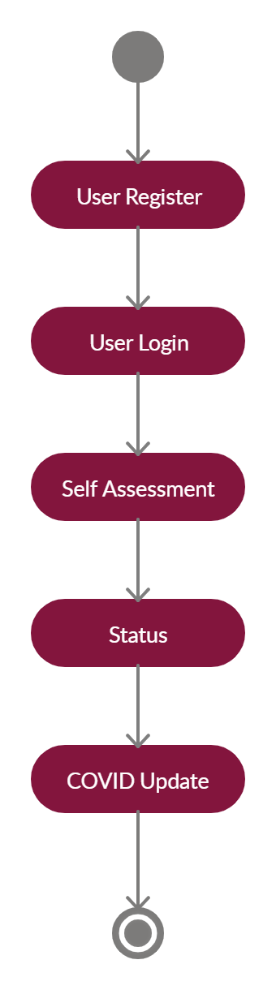

Figure 6:- Statechart diagram of user in ArogyaSetu

**4.6 Sequence Diagram**

A sequence diagram is structured in such a way that it represents a timeline which begins at the top and descends gradually to mark the sequence of interactions. Each object has a column and the messages exchanged between them are represented by arrows.

Sequence diagrams, commonly used by developers, model the interactions between objects in a single use case. They illustrate how the different parts of a system interact with each other to carry out a function, and the order in which the interactions occur when a particular use case is executed.

In simpler words, a sequence diagram shows different parts of a system work in a ‘sequence’ to get something done.

**Sequence Diagram for Public**

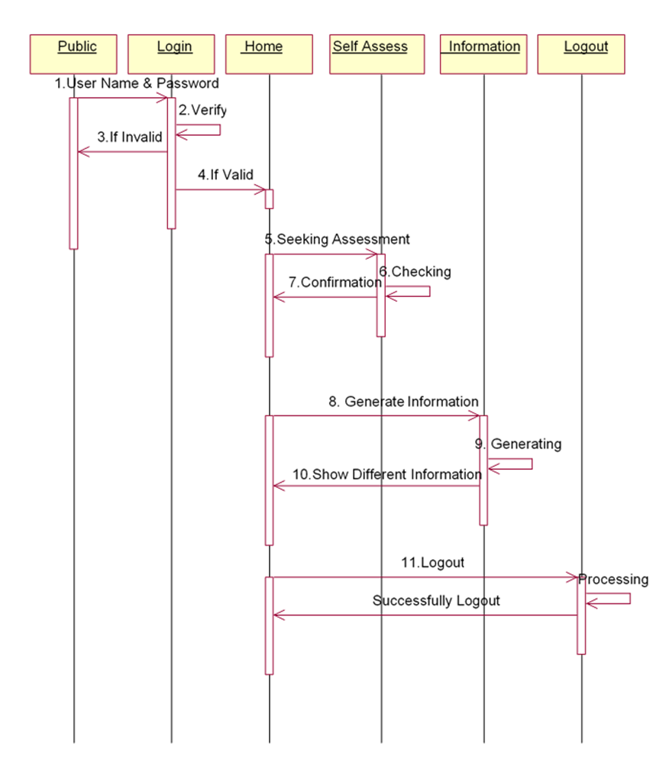

**Sequence Diagram for Admin**

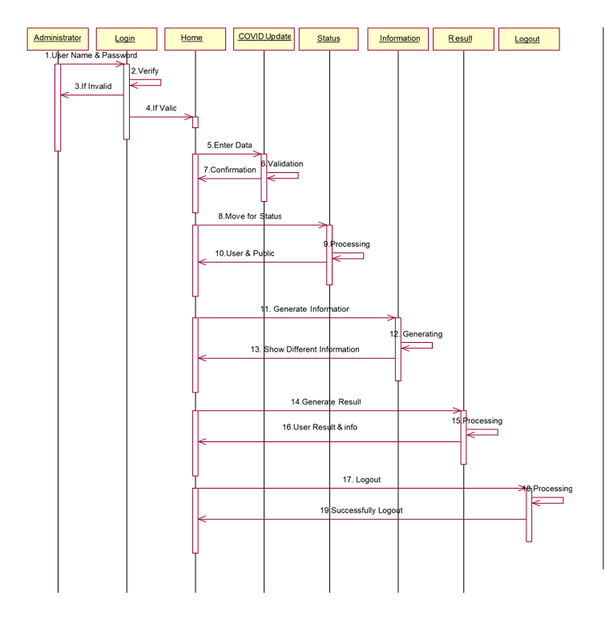

**4.7 Entity-Relationship Diagram**

**Entity Relational (ER) Model** is a high-level conceptual data model diagram. ER modeling helps you to analyse data requirements systematically to produce a well-designed database. The Entity-Relation model represents real-world entities and the relationship between them. It is considered a best practice to complete ER modeling before implementing your database.

**Entity-Relationship Diagram (ERD)** displays the relationships of entity set stored in a database. In other words, we can say that ER diagrams help you to explain the logical structure of databases. At first look, an ER diagram looks very similar to the flowchart. However, ER Diagram includes many specialized symbols, and its meanings make this model unique. The purpose of ER Diagram is to represent the entity framework infrastructure.

This model is based on three basic concepts:

* Entities
* Attributes
* Relationships

**Examples of entities:**

* **Person:** Employee, Student, Patient
* **Place:** Store, Building
* **Object:** Machine, product, and Car
* **Event:** Sale, Registration, Renewal
* **Concept:** Account, Course

**Entity Set**

An entity set is a group of similar kind of entities. It may contain entities with attribute sharing similar values. Entities are represented by their properties, which also called attributes. All attributes have their separate values.

**Relationship**

Relationship is nothing but an association among two or more entities. Entities take part in relationships. We can often identify relationships with verbs or verb phrases.

**Attributes**

It is a single-valued property of either an entity-type or a relationship-type.An attribute is represented by an Ellipse

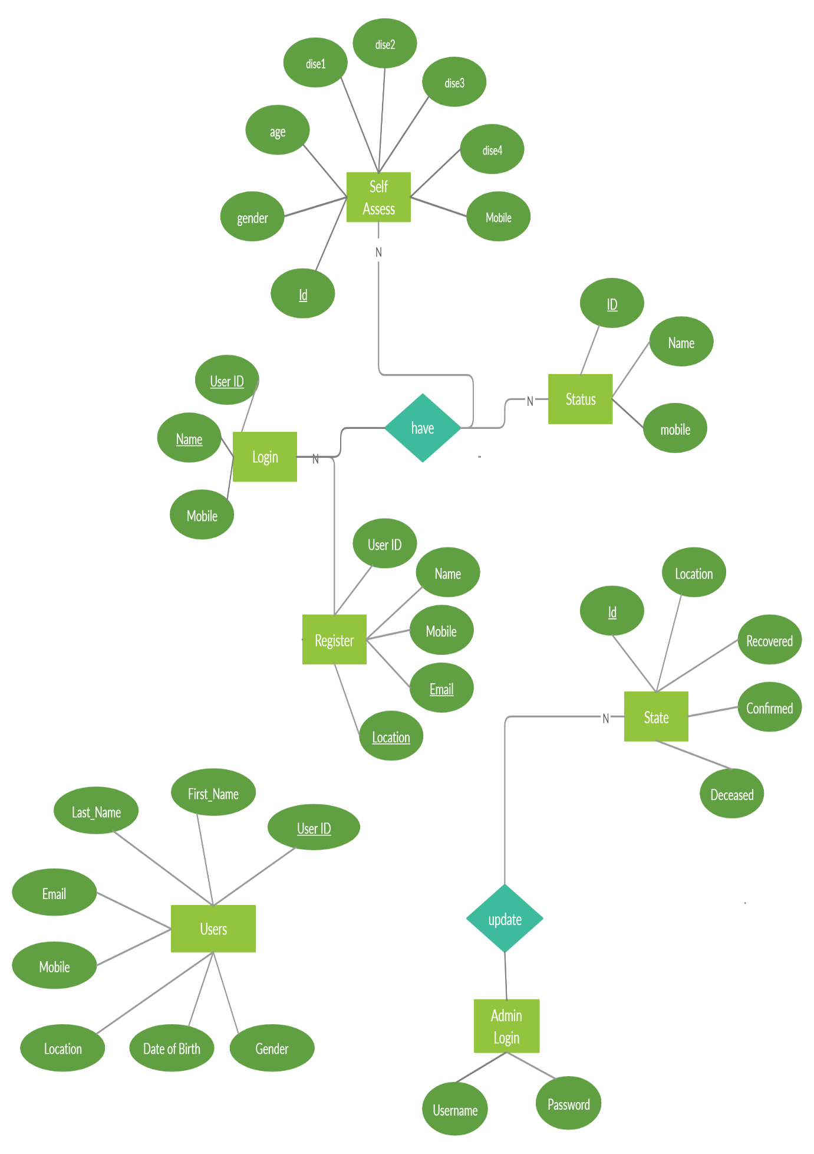

Figure 6 ER Diagram of ArogyaSetu

**4.8 Data Flow Diagram**

A Data Flow Diagram (DFD) is a traditional way to visualize the information flows within a system. A neat and clear DFD can depict a good amount of the system requirements graphically. It can be manual, automated, or a combination of both.

It shows how information enters and leaves the system, what changes the information and where information is stored. The purpose of a DFD is to show the scope and boundaries of a system as a whole. It may be used as a communications tool between a systems analyst and any person who plays a part in the system that acts as the starting point for redesigning a system.

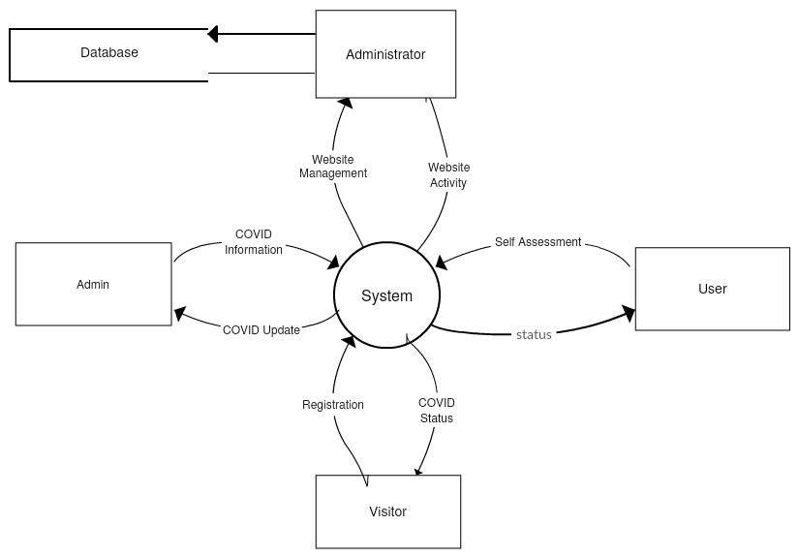

DFD level 0 of Website

**Database Design**

**1. arogyasetu_login table**

|  |  |  |
| --- | --- | --- |
| **Name** | **Type** | **Constraints** |
| id | integer | Primary Key |
| name | varchar(50) |  |
| mobile | integer |  |

**2. arogyasetu_register table**

|  |  |  |
| --- | --- | --- |
| **Name** | **Type** | **Constraints** |
| id | integer | Primary Key |
| name | varchar(50) |  |
| mobile | integer |  |
| email | varchar(256) |  |
| location | varchar(50) |  |

**3. arogyasetu_state table**

|  |  |  |
| --- | --- | --- |
| **Name** | **Type** | **Constraints** |
| id | integer | Primary Key |
| location | varchar(50) |  |
| recovered | integer |  |
| confirmed | integer |  |
| deceased | integer |  |

**4. arogyasetu_test table**

|  |  |  |
| --- | --- | --- |
| **Name** | **Type** | **Constraints** |
| id | integer | Primary Key |
| gender | varchar(30) |  |
| age | integer |  |
| dise1 | varchar(100) |  |
| dise2 | varchar(100) |  |
| dise3 | varchar(100) |  |
| dise4 | varchar(100) |  |
| mobile | integer |  |

**5. auth_group table**

|  |  |  |
| --- | --- | --- |
| **Name** | **Type** | **Constraints** |
| id | integer | Primary Key |
| name | varchar(150) |  |

**6. auth_group_permissions table**

|  |  |  |
| --- | --- | --- |
| **Name** | **Type** | **Constraints** |
| id | integer | Primary Key |
| group_id | integer |  |
| permission_id | integer |  |

**7. auth_permission table**

|  |  |  |
| --- | --- | --- |
| **Name** | **Type** | **Constraints** |
| id | integer | Primary Key |
| content_type_id | integer |  |
| codename | varchar(100) |  |
| name | varchar(255) |  |

**8. auth_user table**

|  |  |  |
| --- | --- | --- |
| **Name** | **Type** | **Constraints** |
| id | integer | Primary Key |
| password | varchar(128) |  |
| last_login | datetime |  |
| Is_superuser | bool |  |
| Username | varchar(150) |  |
| first_name | varchar(30) |  |
| email | varchar(254) |  |
| is_staff | bool |  |
| is_active | bool |  |
| date_joined | datetime |  |
| last_name | varchar(150) |  |

**9. auth_user_groups table**

|  |  |  |
| --- | --- | --- |
| **Name** | **Type** | **Constraints** |
| id | integer | Primary Key |
| user_id | integer |  |
| group_id | integer |  |

**10. auth_user_user_permissions table**

|  |  |  |
| --- | --- | --- |
| **Name** | **Type** | **Constraints** |
| id | integer | Primary Key |
| user_id | integer |  |
| permission_id | integer |  |

**11. django_admin_log table**

|  |  |  |
| --- | --- | --- |
| **Name** | **Type** | **Constraints** |
| id | integer | Primary Key |
| action_time | datetime |  |
| object_id | text |  |
| object_repr | varchar(200) |  |
| change_message | text |  |
| content_type_id | integer |  |
| user_id | integer |  |
| action_flag | smallint unsigned |  |

**12. django_content_type table**

|  |  |  |
| --- | --- | --- |
| **Name** | **Type** | **Constraints** |
| id | integer | Primary Key |
| app_label | varchar(100) |  |
| model | varchar(100) |  |

**13. django_migrations table**

|  |  |  |
| --- | --- | --- |
| **Name** | **Type** | **Constraints** |
| id | integer | Primary Key |
| app | varchar(255) |  |
| name | varchar(255) |  |
| applied | datetime |  |

**14. django_session table**

|  |  |  |
| --- | --- | --- |
| **Name** | **Type** | **Constraints** |
| session_key | varchar(40) | Primary Key |
| session_data | text |  |
| expire_date | datetime |  |

**Project Implementation and Output Screen**

**6.1 Screenshots of Projects**

**ArogyaSetu Home Page**

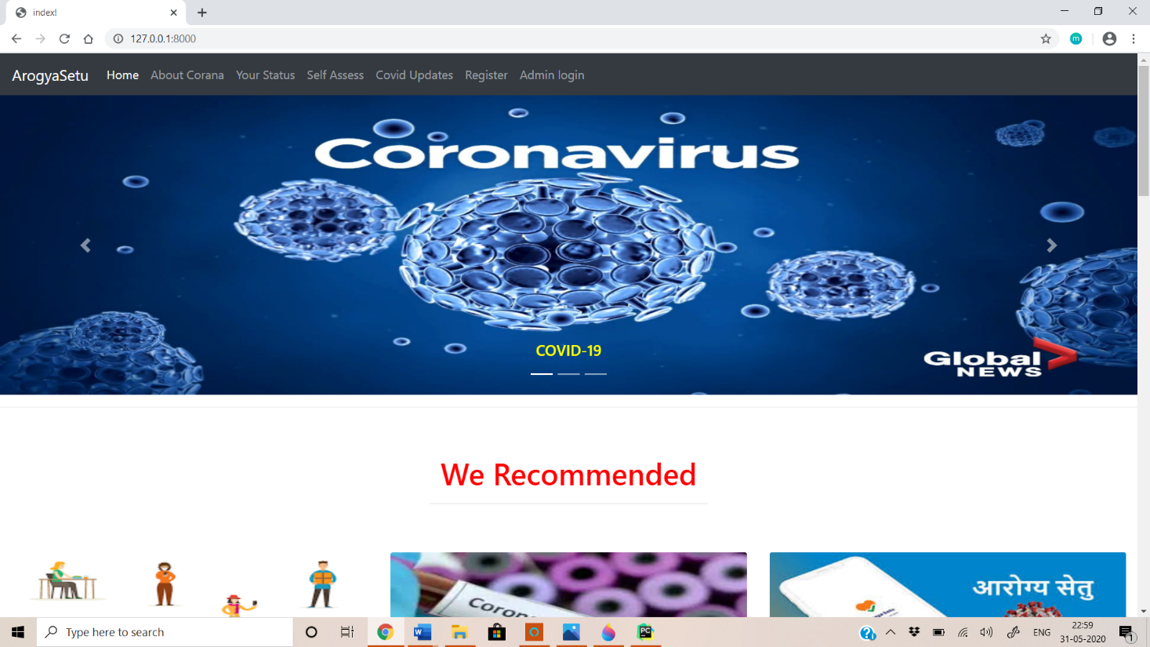

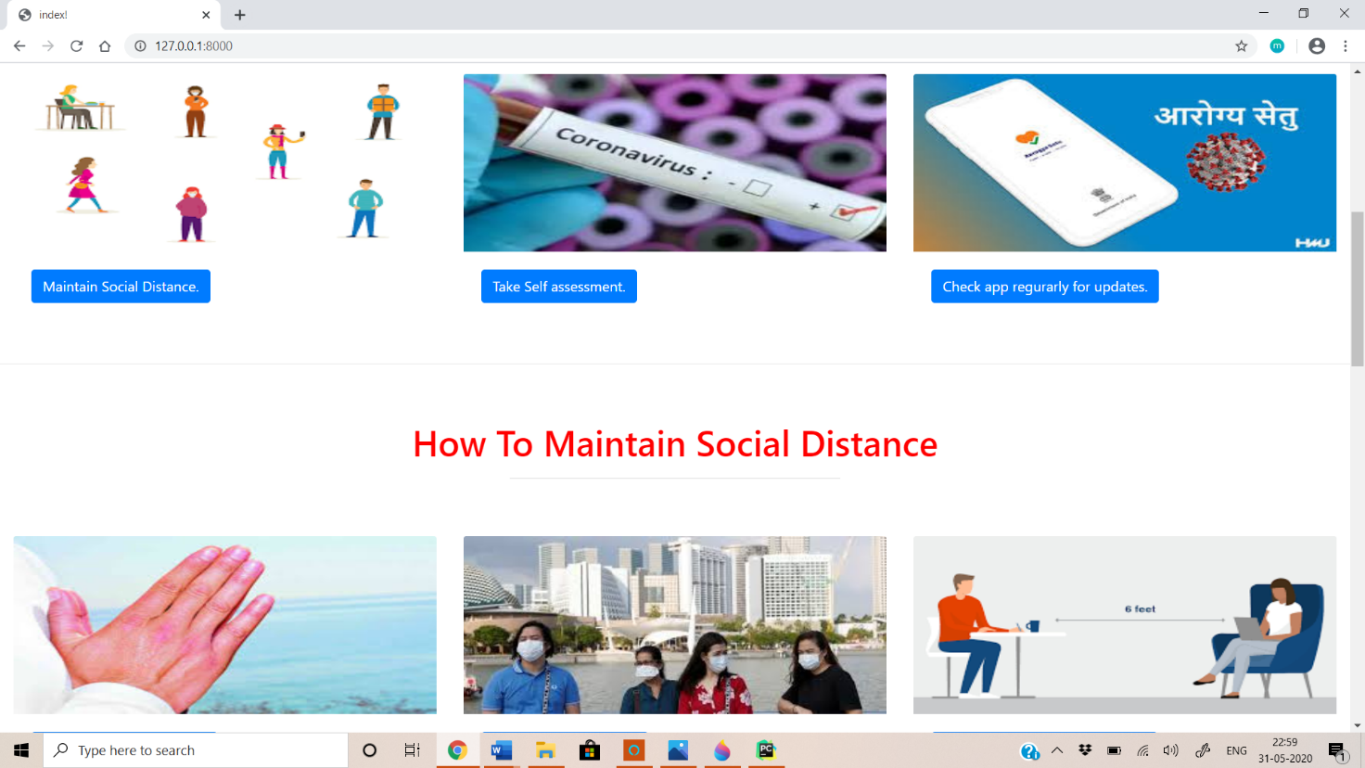

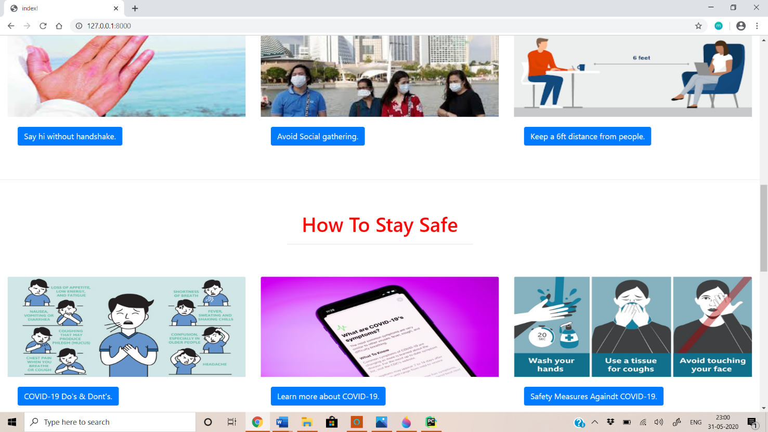

**ArogyaSetu Registration Page**

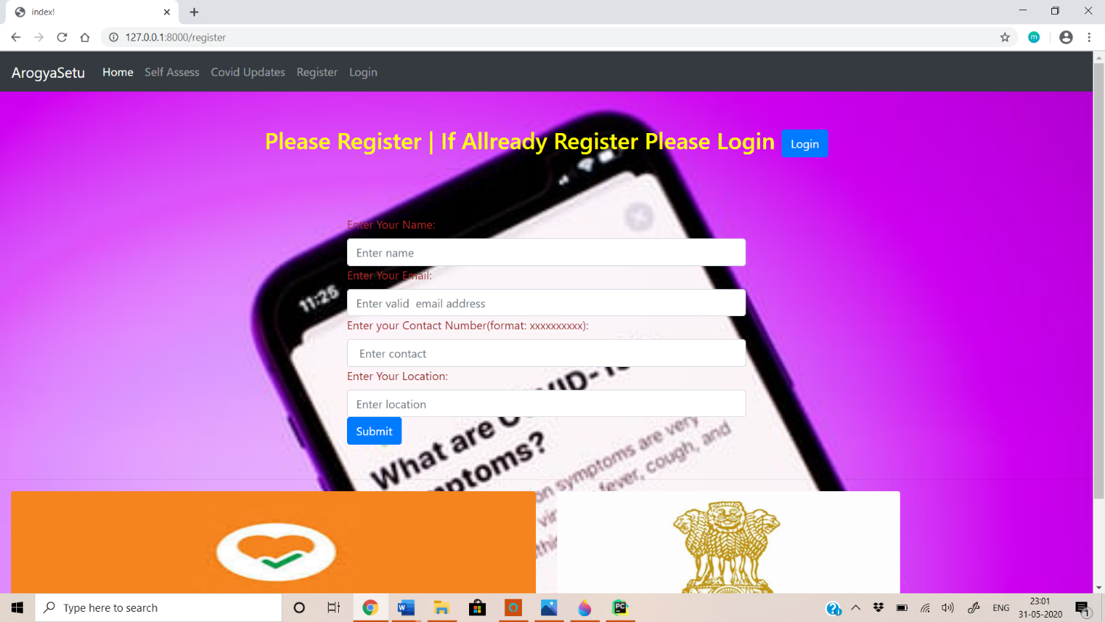

**ArogyaSetu Login Page**

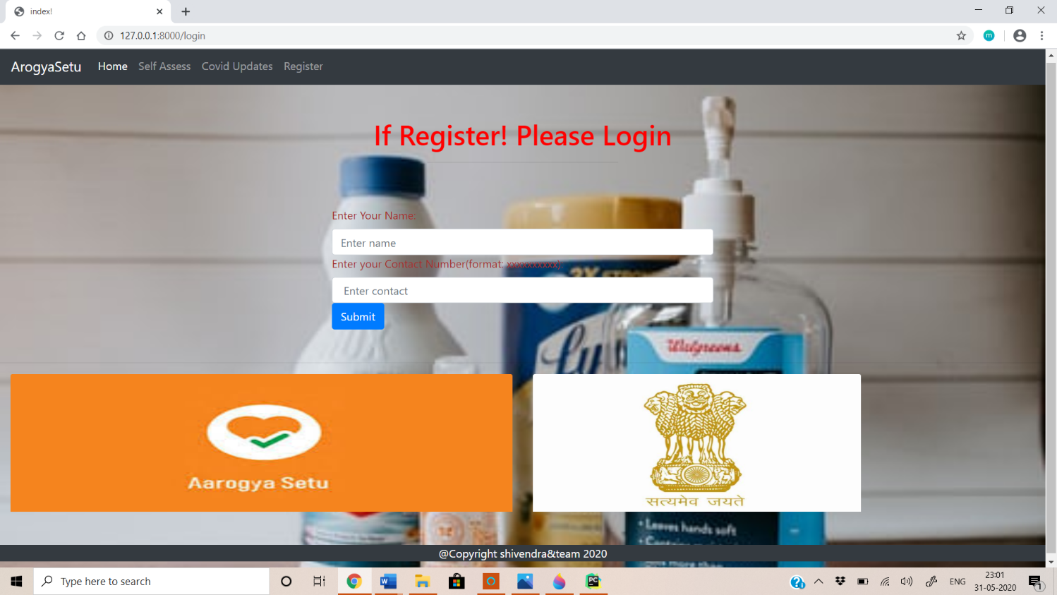

**ArogyaSetu Self-Assessment Page**

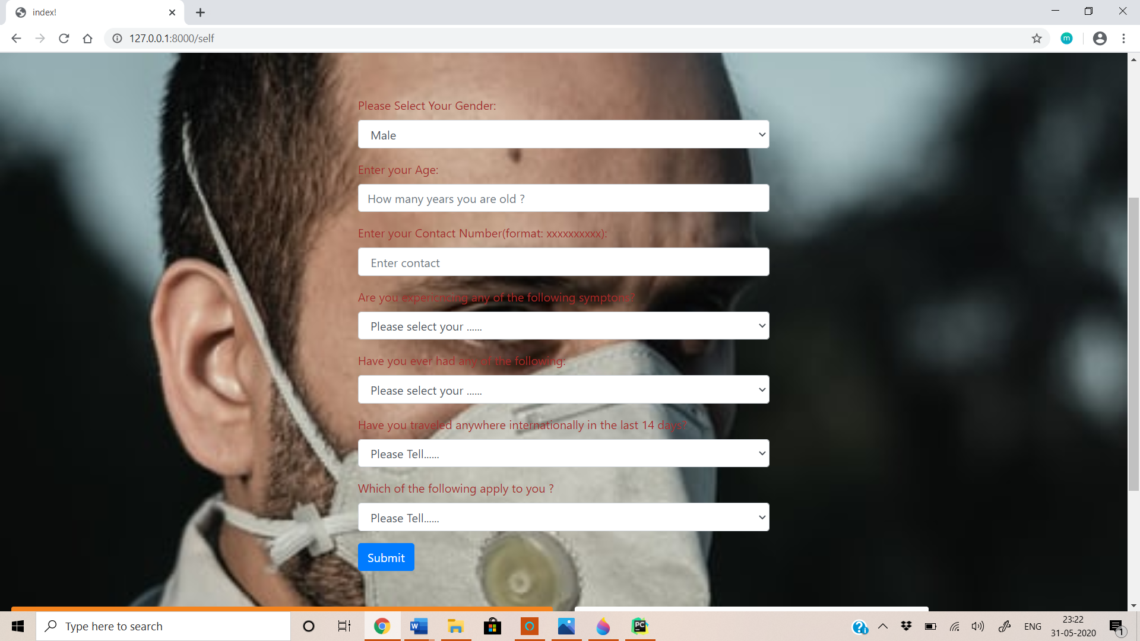

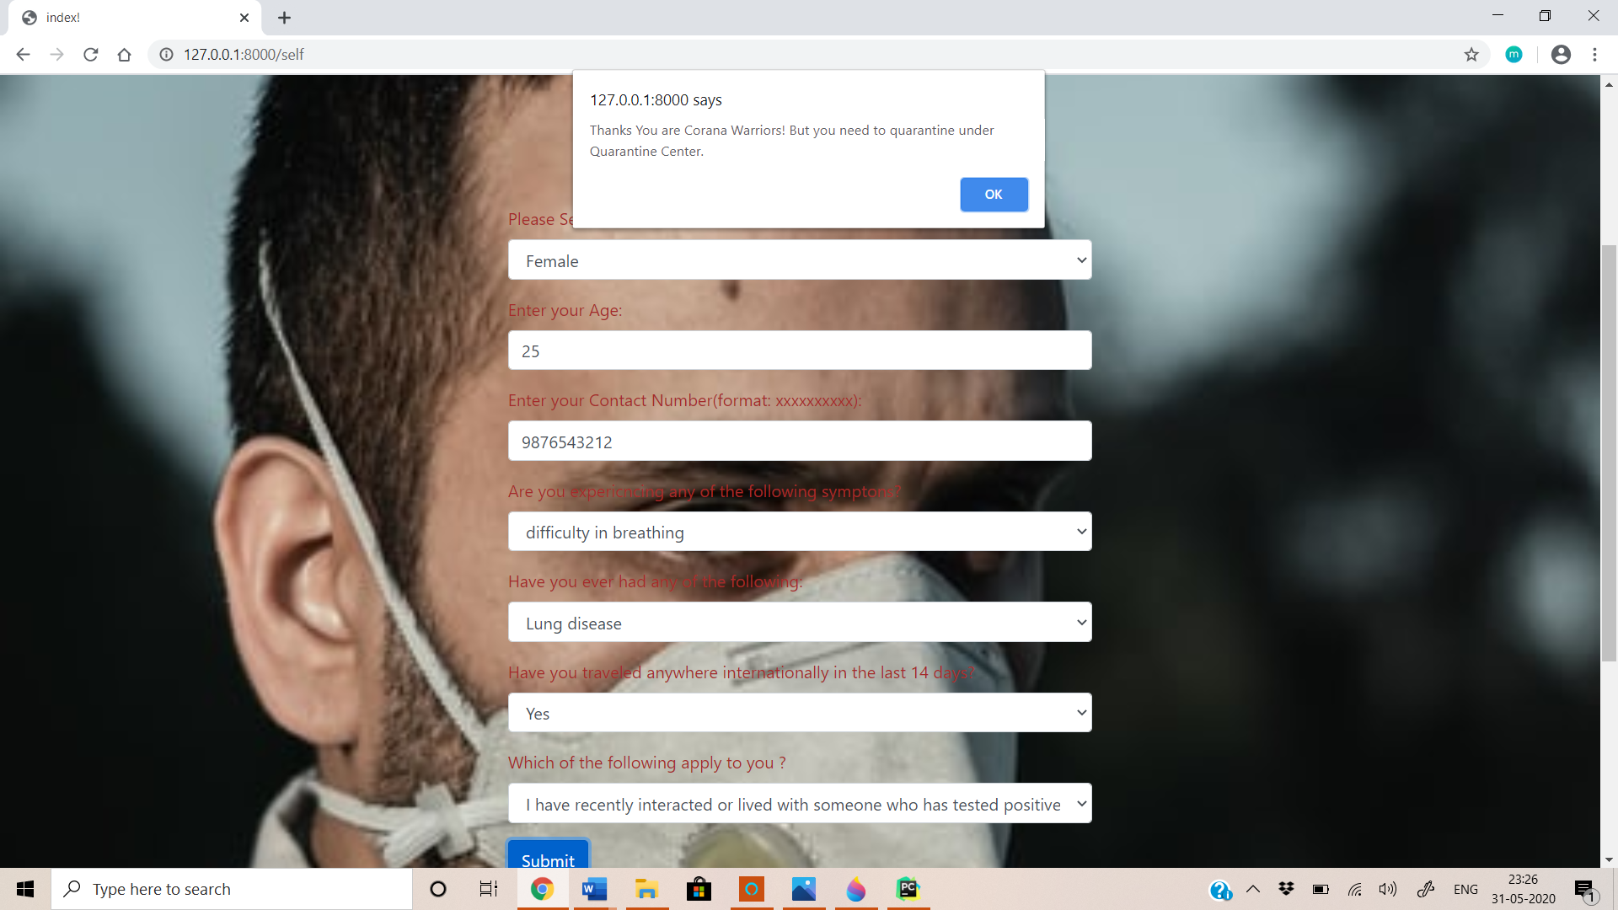

**ArogyaSetu COVID Update Page**

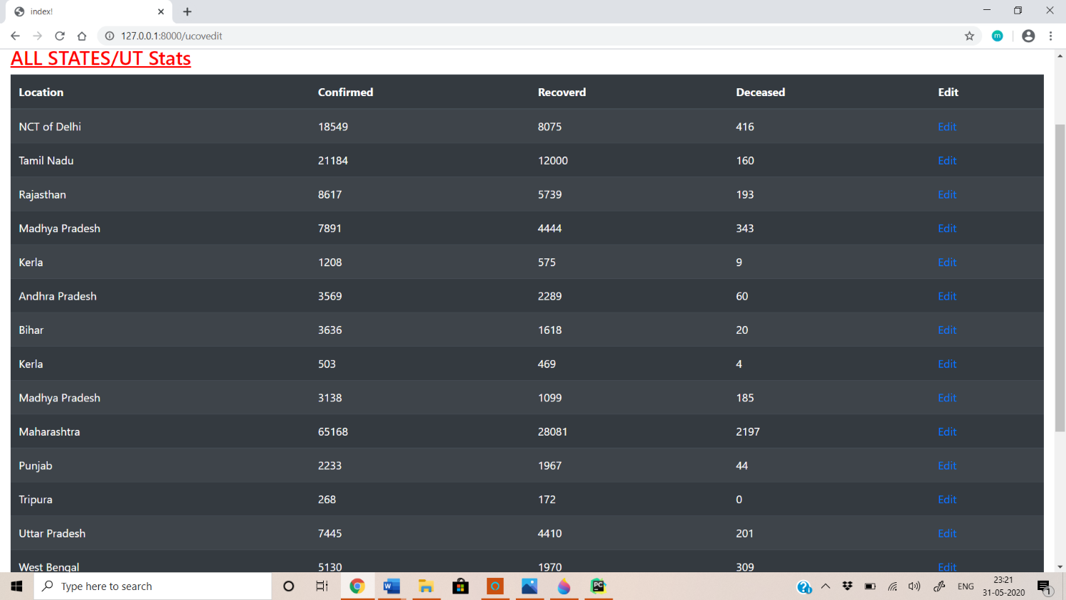

**6.2 Some code snippets**

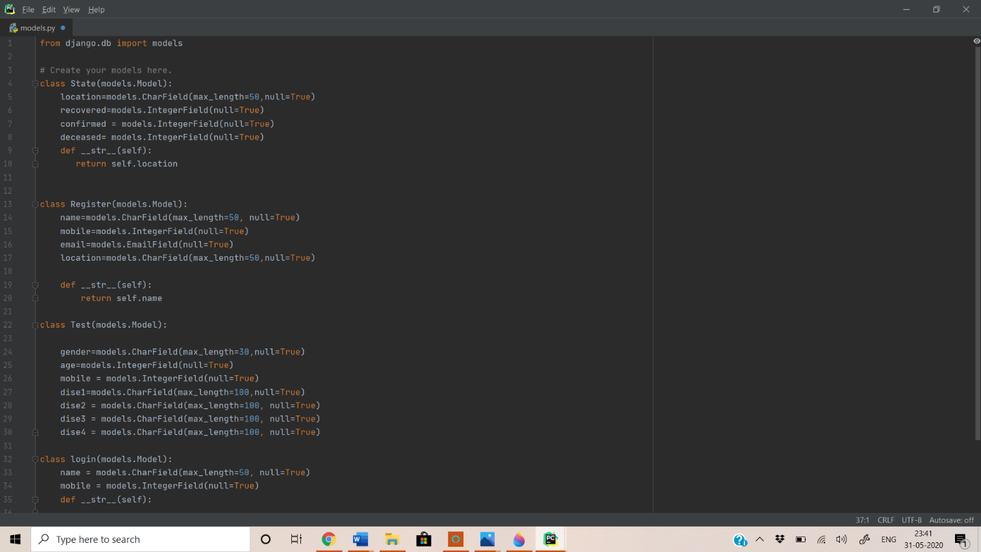

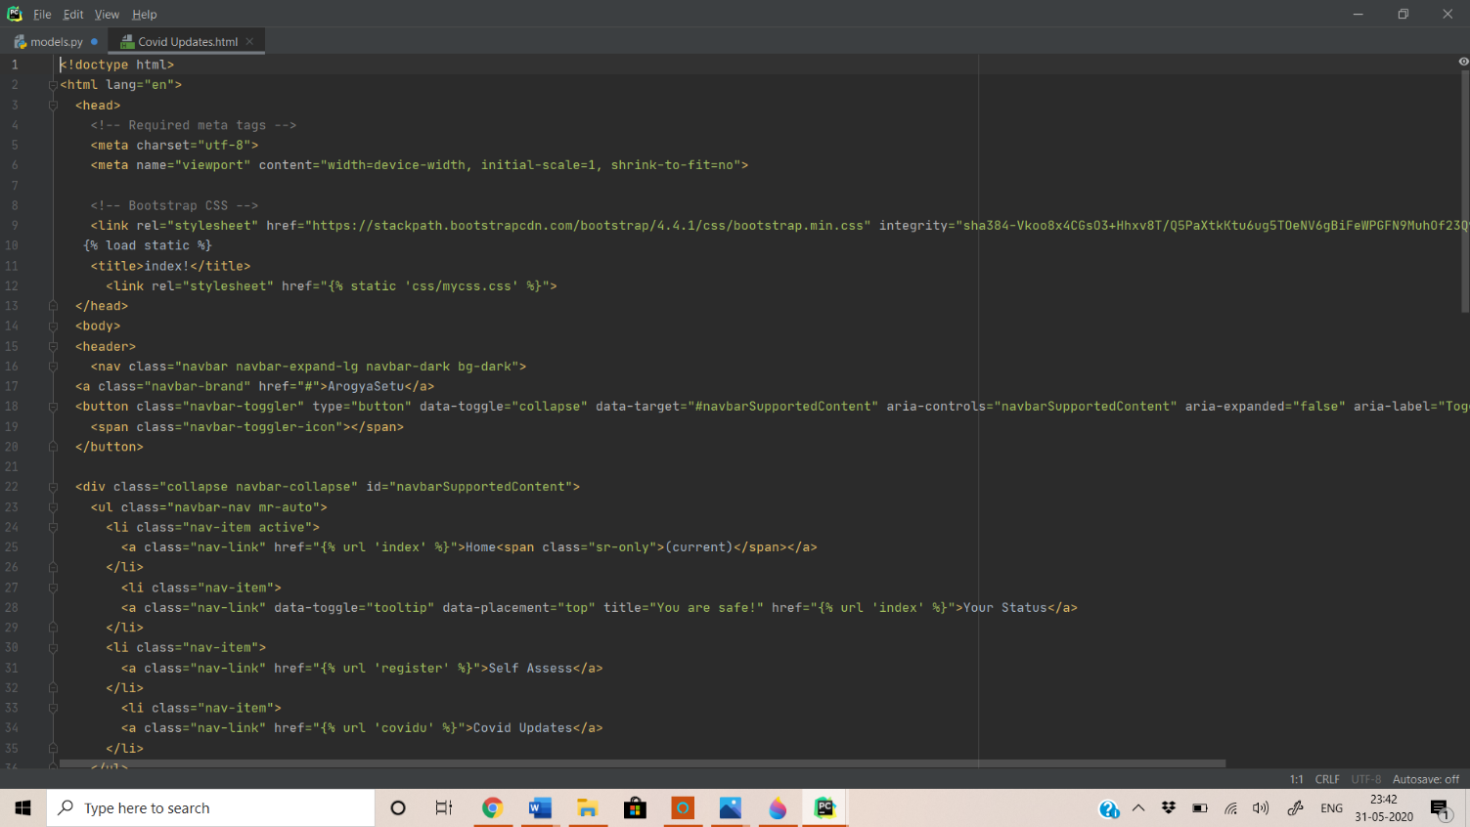

**Testing**

**7.1 Testing Strategies Adopted**

As there are two types of testing strategies namely Black box testing and White box testing and we have performed both kind of testing in our software.

**Testing Methodologies**

* **Black box Testing**: is the testing process in which tester can perform testing on an application without having any internal structural knowledge of application.

Usually Test Engineers are involved in the black box testing.

* **White box Testing**: is the testing process in which tester can perform testing on an application with having internal structural knowledge.

Usually the Developers are involved in white box testing.

* **Gray Box Testing**: is the process in which the combination of black box and white box techniques are used.

**Black-Box Testing**

The black box approach is a testing method in which test data are derived from the specified functional requirement without regard to the final program structure. It is also termed data driven; input/output driven or requirements- based testing. Because only the functionality of the software module is of concern, black- box testing also refer to the functional testing, a testing method emphasized on executing the function and examination of their input and output data. The tester treats the software under test as a black box only the input, output and specification are visible, and the functionality is determined by observing the output of corresponding input.

In testing, various inputs are exercised and the outputs are compared against specification to validate the correctness. All the test cases are derived from the specification. No implementation details of the code are considered.

**White-Box Testing**

White box testing, sometimes called glass-box testing is a test case design method that uses the control structure of the procedural design to drive test cases. Using white-box testing methods, the software engineer can derive test cases that

1. Guarantee that all independent paths within a module have been exercised at least once.
2. Exercise all logical decision on their true and false sides.
3. Execute all loops their boundaries and within their operational bounds.
4. Exercise internal data structure to ensure their validity.

**7.2 System Testing**

1. System testing is the testing to ensure that by putting the software in different environments (e.g., Operating Systems) it still works. System testing is done with full system implementation and environment. It falls under the class of black box testing.
2. System Testing (ST) is a black box testing technique performed to evaluate the complete system the system's compliance against specified requirements. In System testing, the functionalities of the system are tested from an end-to-end perspective.
3. System Testing is usually carried out by a team that is independent of the development team in order to measure the quality of the system unbiased. It includes both functional and Non-Functional testing.

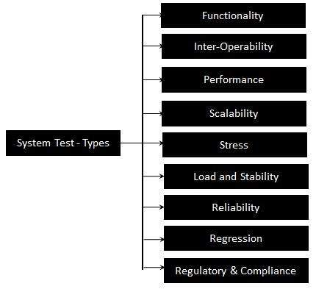

Figure :- System Testing Types

**7.3 Unit testing:**

Unit testing is the testing of an individual unit or group of related units. It falls under the class of white box testing. It is often done by the programmer to test that the unit he/she has implemented is producing expected output against given input.

The following are the tests that are performed during the unit testing:

**Data Fetch from server using Async Methods: -** To check bus session and coordinates information fetched through server.

1. **Network Failures: -** To check network failures if any while data transmission between client and server.
2. **Boundary Conditions: -** It is observed that much software fails at boundary conditions. That’s why boundary conditions are tested to ensure that the program is properly working at its boundary conditions.
3. **Independent Paths: -** All independent paths are tested to see that they are properly executing their task and terminating at the end of program.

**7.4 Test plan & test cases**

**Test Cases:**

|  |  |  |  |
| --- | --- | --- | --- |
| **Test Case Number** | **Test Case** | **Description** | **Test Result** |
| T-001 | Self Assessment | There are appropriate results of test | Successful |
| T-002 | COVID Updates | Updates of many request without interruption | Successful |
| T-003 | Contributors | Give a new activity with name of contributors | Successful |
| T-004 | Modularity Test | To check if module work well on different systems or not | Successful |

Table - Test Case

**7.5 Types of Testing**

* **Smoke Testing**: is the process of initial testing in which tester looks for the availability of all the functionality of the application in order to perform detailed testing on them. (Main check is for available forms)
* **Sanity Testing:** is a type of testing that is conducted on an application initially to check for the proper behaviour of an application that is to check all the functionality are available before the detailed testing is conducted by on them.
* **Regression Testing:** is one of the best and important testing. Regression testing is the process in which the functionality, which is already tested before, is once again tested whenever some new change is added in order to check whether the existing functionality remains same.
* **Re-Testing:** is the process in which testing is performed on some functionality which is already tested before to make sure that the defects are reproducible and to rule out the environment’s issues if at all any defects are there.
* **Static Testing:** is the testing, which is performed on an application when it is not been executed. ex: GUI, Document Testing
* **Dynamic Testing:** is the testing which is performed on an application when it is being executed. ex: Functional testing.
* **Alpha Testing:** it is a type of user acceptance testing, which is conducted on an application when it is just before released to the customer.
* **Monkey Testing:** is the process in which abnormal operations, beyond capacity operations are done on the application to check the stability of it in spite of the users abnormal behaviour.
* **Compatibility testing:** it is the testing process in which usually the products are tested on the environments with different combinations of databases (application servers, browsers…etc) In order to check how far the product is compatible with all these environments platform combination.
* **Installation Testing:** it is the process of testing in which the tester try to install or try to deploy the module into the corresponding environment by following the guidelines produced in the deployment document and check whether the installation is successful or not.
* **Adhoc Testing:** Adhoc Testing is the process of testing in which unlike the formal testing where in test case document is used, without that test case document testing can be done of an application, to cover that testing of the future which are not covered in that test case document. Also, it is intended to perform GUI testing which may involve the issues.

**Levels of testing**

|  |  |  |  |  |  |  |  |  |  |  |  |  |  |  |  |
| --- | --- | --- | --- | --- | --- | --- | --- | --- | --- | --- | --- | --- | --- | --- | --- |
| |  |  |  |  |  |  |  |  |  |  |  |  |  |  |  | | --- | --- | --- | --- | --- | --- | --- | --- | --- | --- | --- | --- | --- | --- | --- | | ***Module1*** ***Module2*** ***Module3***   |  |  |  |  |  |  |  |  |  |  |  |  |  |  | | --- | --- | --- | --- | --- | --- | --- | --- | --- | --- | --- | --- | --- | --- | | ***Units***   |  |  |  | | --- | --- | --- | |  |  |  | |  | ***Units***   |  |  |  | | --- | --- | --- | |  |  |  | |  | ***Units***   |  |  |  | | --- | --- | --- | |  |  |  | |   i/p ***Integration***  o/p i/p ***Integration o/p*** |   ***System Testing: Presentation + business +Databases***  ***🚹UAT: user acceptance testing*** |

**Conclusion**

The main objectives of the project were to develop a web application that will be used to Self Assess or test related to user submitted questions on COVID. To develop a database were all the related data will be stored and to develop a user interface.

A background research took place, which included an overview of the Aarogya setu mobile application and its assessment questions procedure and any relevant COVID website available. A database was developed, which stores information about COVID updates, test questions, result and feedback messages. A usable system was designed, developed and deployed to the web server.

The developed system is a Web Application, used python on the backend & Django web server to develop. As it is a Web Application however it can be viewed in any browser. This makes System Priority Internet i.e. portable.

It provides information regarding COVID, Self-Assessment, Status and updates. User can collect information about COVID through this application. It reduces both man power and time. User does not have to visit different websites to gather information. So to overcome such situations this idea is developed so that user can get any kind of information about anything happening about COVID anytime.

**Appendix :**

**References**

**1.** <https://github.com/nic-delhi/AarogyaSetu_Android>

**2.** <https://medium.com/@frankvolkel/aarogya-setu-under-the-hood-5660860d2374>